INSTALLATION EXERCISES

EXERCISE 2 → Install Windows 10 with the configurations asked

Now we are required to make some more configurations. We need to have the extension pack installed for some of these configurations. If we did not install it before, we can install it now and import it on VirtualBox, then power off our machine and we will be able to change these settings .
These ones will let us enjoy of a more complete experience:

Firstly, we will have to go to “USB” and tick “USB 3.0” to have the 3.0 support in our virtual machine.
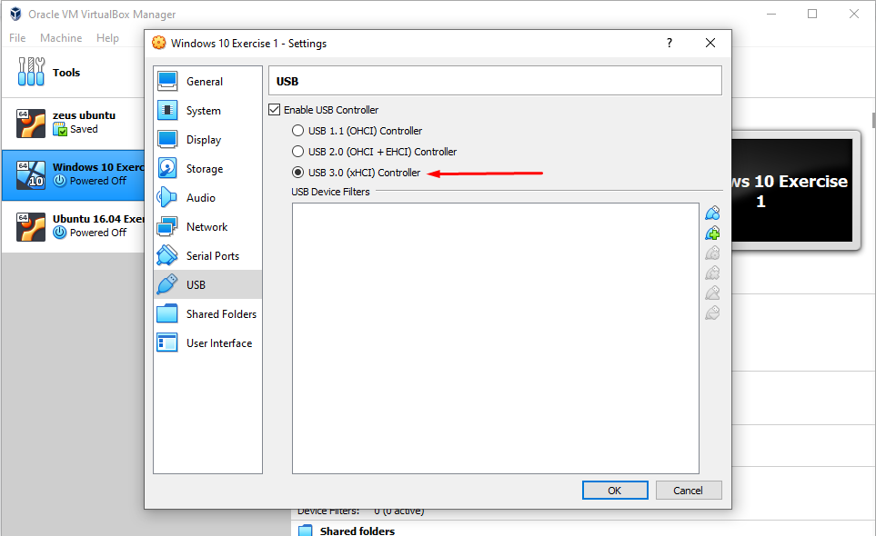

Secondly, we have to go to “Shared Folders” and create a new one. We need to set the file location, its name and tick “Auto-mount”. This, as its name says, will create a folder shared by both, the virtual machine and the physical computer.
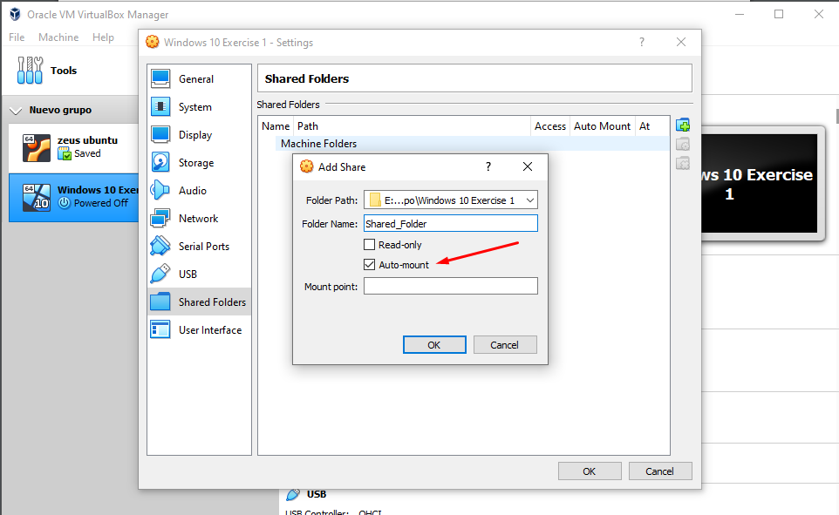

Thirdly, we will have to click “Network” and change the “attached to” option from “NAT” to “Bridged Adapter”. This will let us have internet connection and also have access to the rest of the computers of the network.
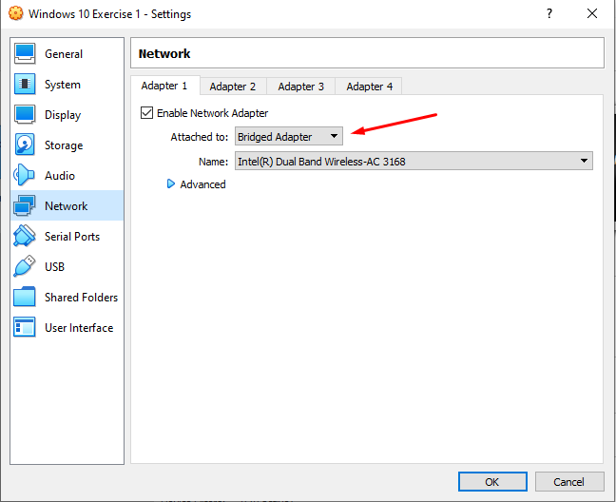
Finally, we need to go to “General”, “Advanced” and change both “Shared clipboard” and “Drag’n Drop” to “Bidirectional”. This together with a later configuration will let us copy and past from the host to the guest and vice versa.
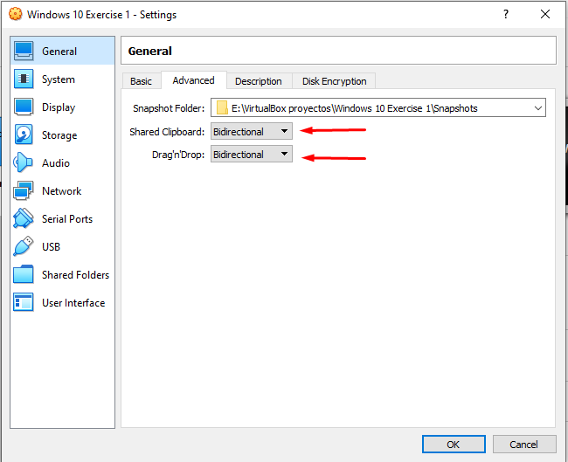

WINDOWS INSTALLATION:
Now we have finished setting our machine and now it is time to install Windows 10.
In “settings” we will need to go to storage and click on the CD Image that says “Empty” and then click on the pointed out icon.
After that, we need to select the ISO File we want to use (it will be Windows 10 64bit), click OK and press the “Start” button.

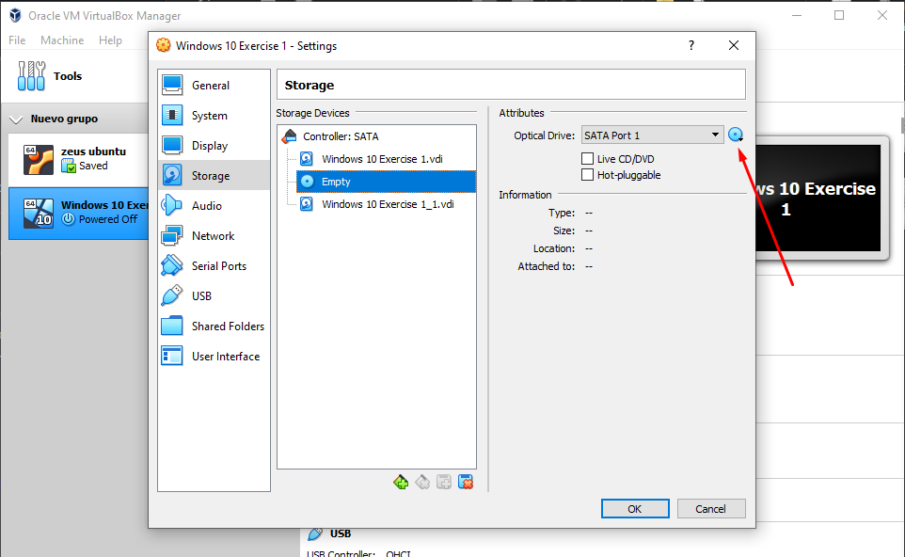

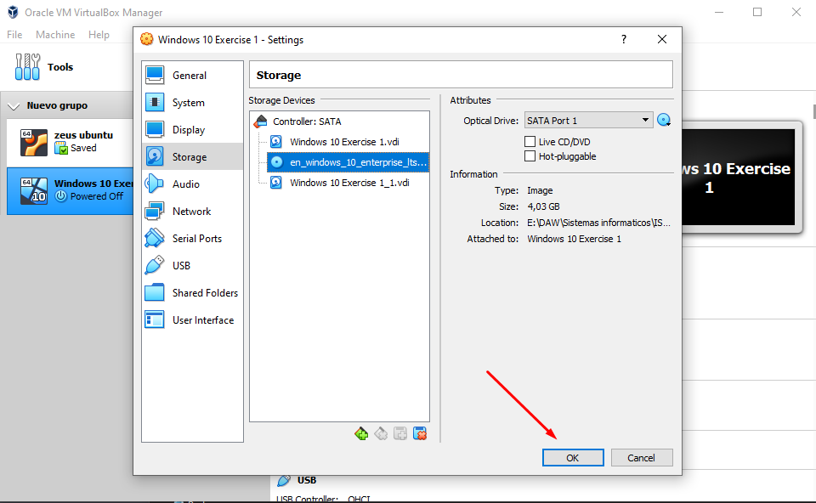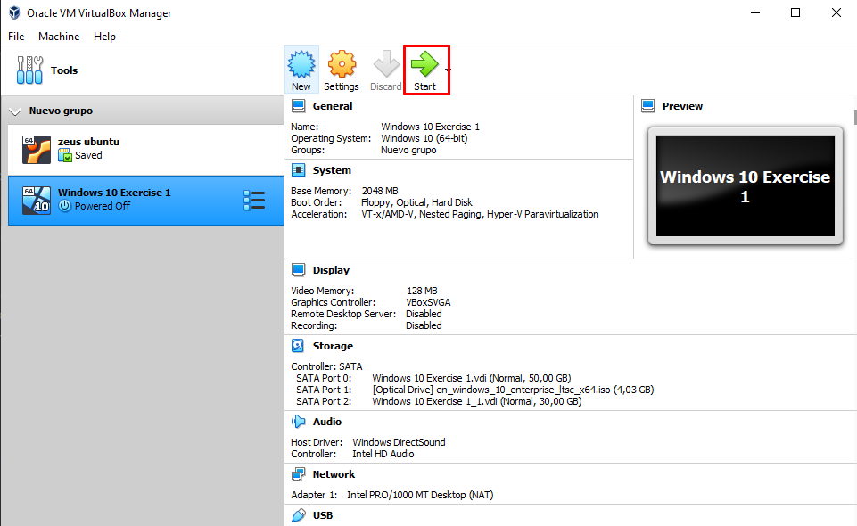

After doing this, our Windows’ interface will appear. Now it is time to install it.
(Warning: all these settings can be different, whenever is more comfortable for the user)

First we must change the time and the keyboard method to Spanish (in this case we will leave the language in English. After this, click “Install”.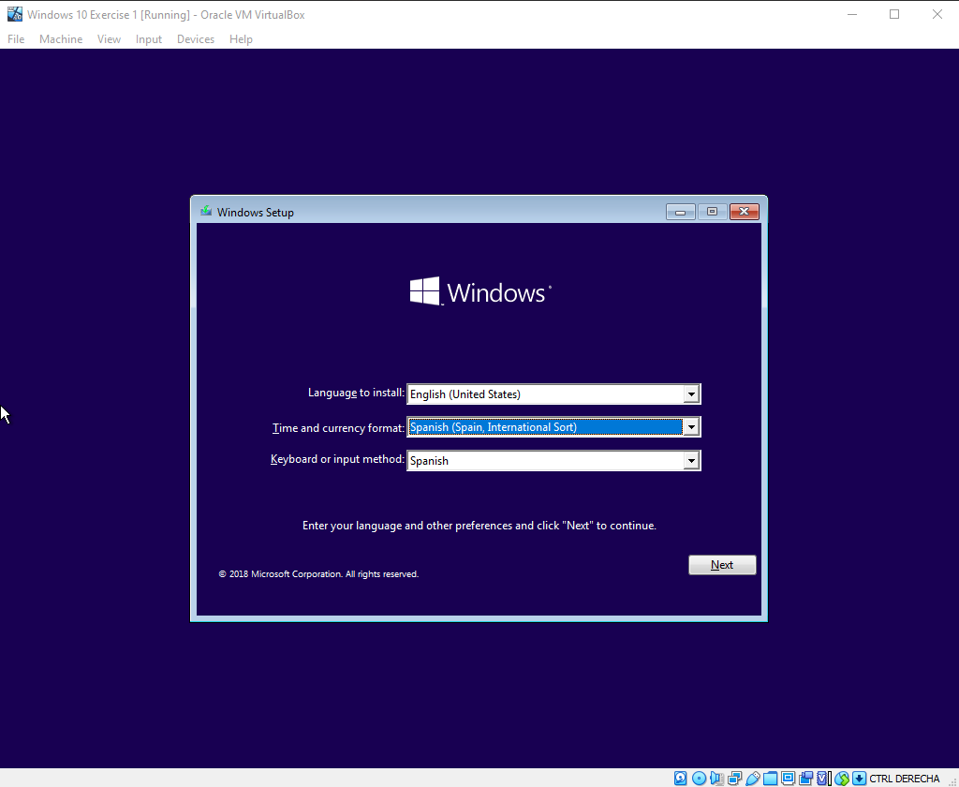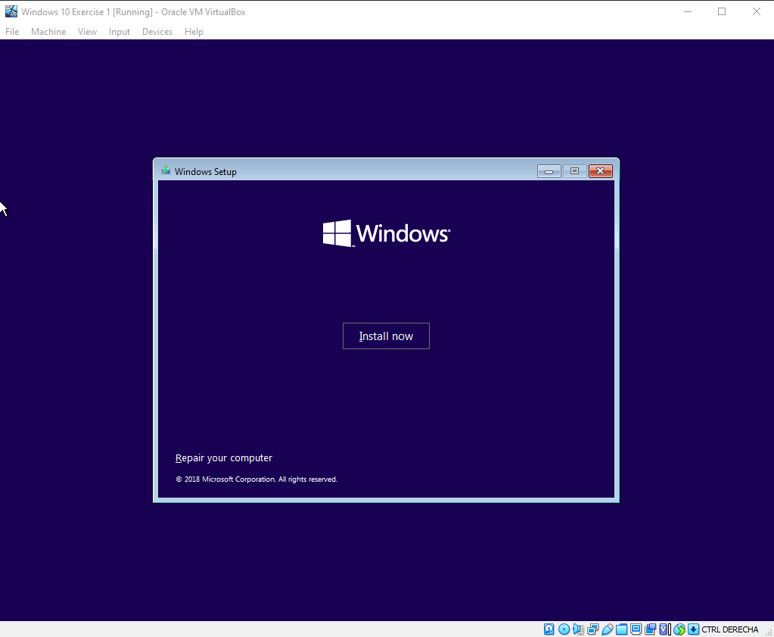
Now we need to select the operating system we want to install (which is the first one it appears).
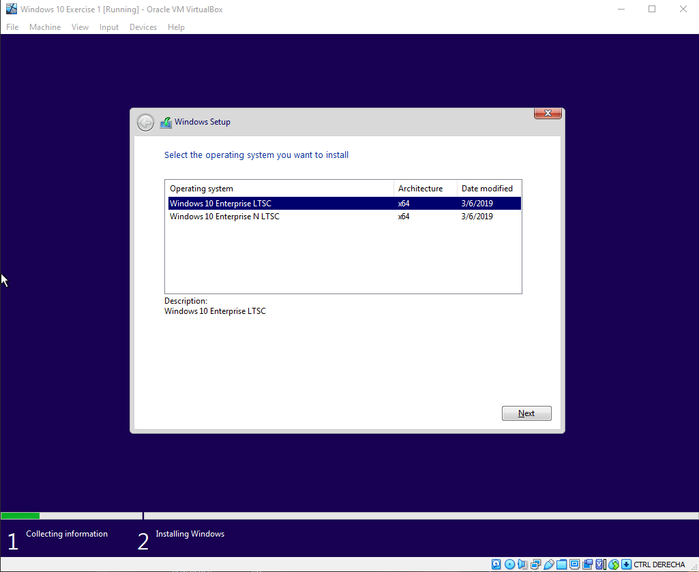

After this we will need to accept the license terms and we will start our “Custom Installation”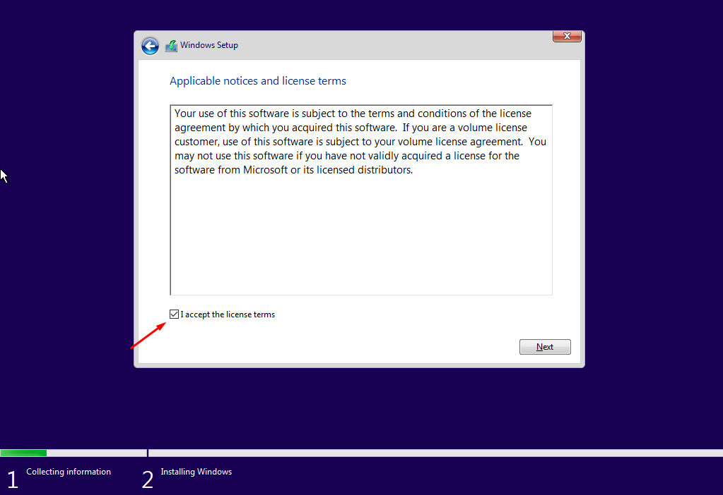
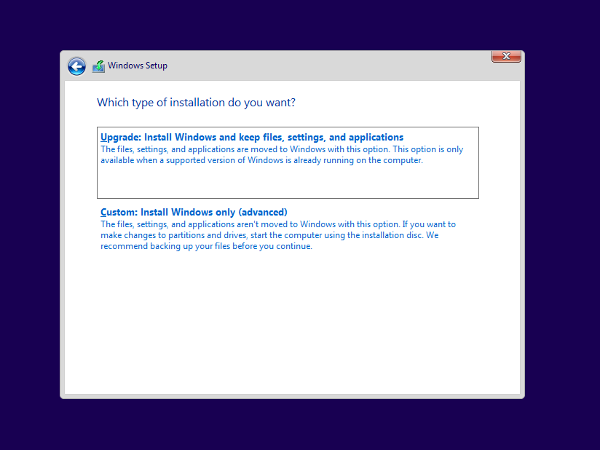

Now, the system will ask us where do we want to install it, so we will have to choose between our different memory sets. In this case, we have our 50GB and 30GB hard drives. For this exercise we will install Windows on the 50GB hard drive, but you can also click on “New” to make a partition from the selected drive. This is to make a memory reservation, for example, for the operating system (but as we said, this is not necessary for our exercise).
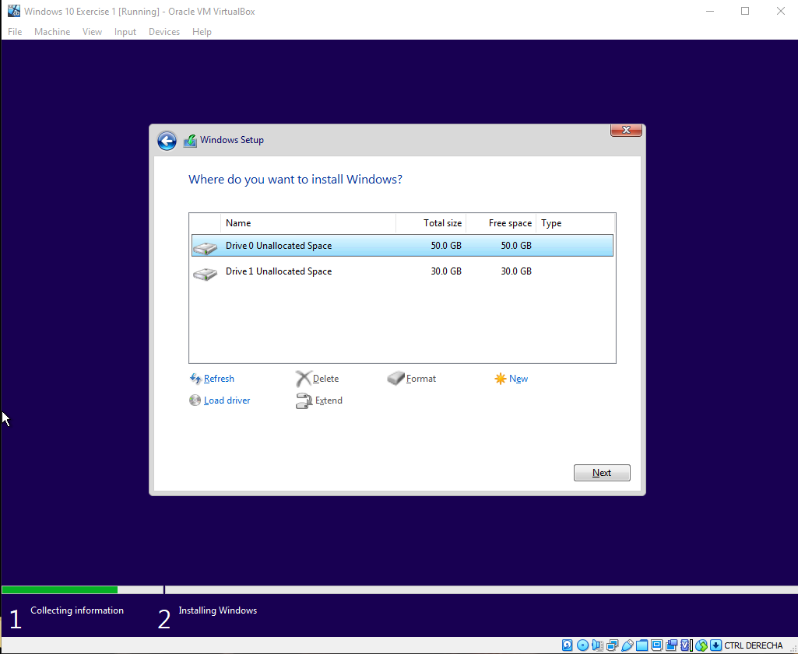

When finished, the system itself will finish the settings and a new interface will appear for you to choose the settings you prefer for your personalized use of Windows.

In this example we will configure it as I consider it is the best way to do it, taking care of our personal information and security for our computer.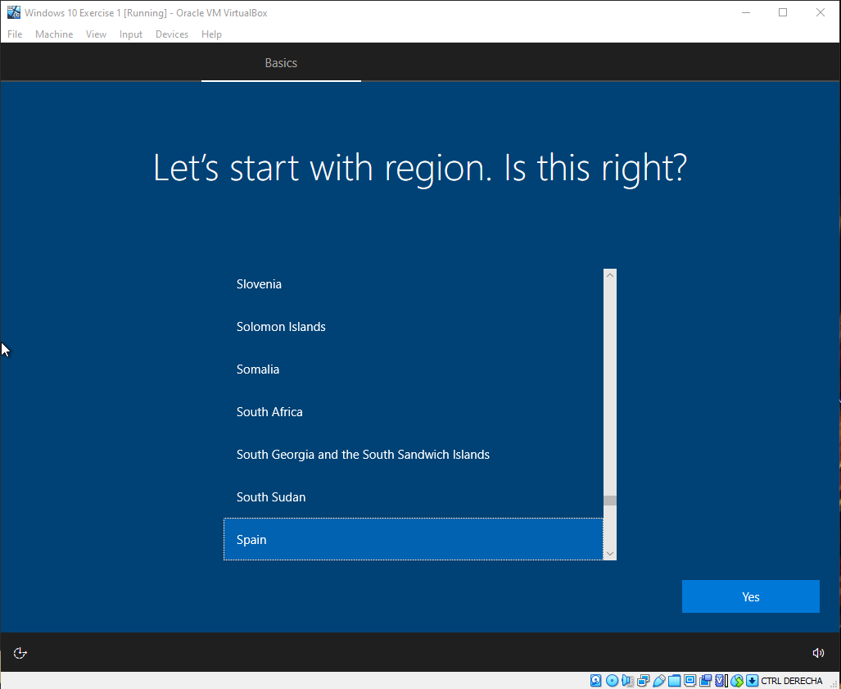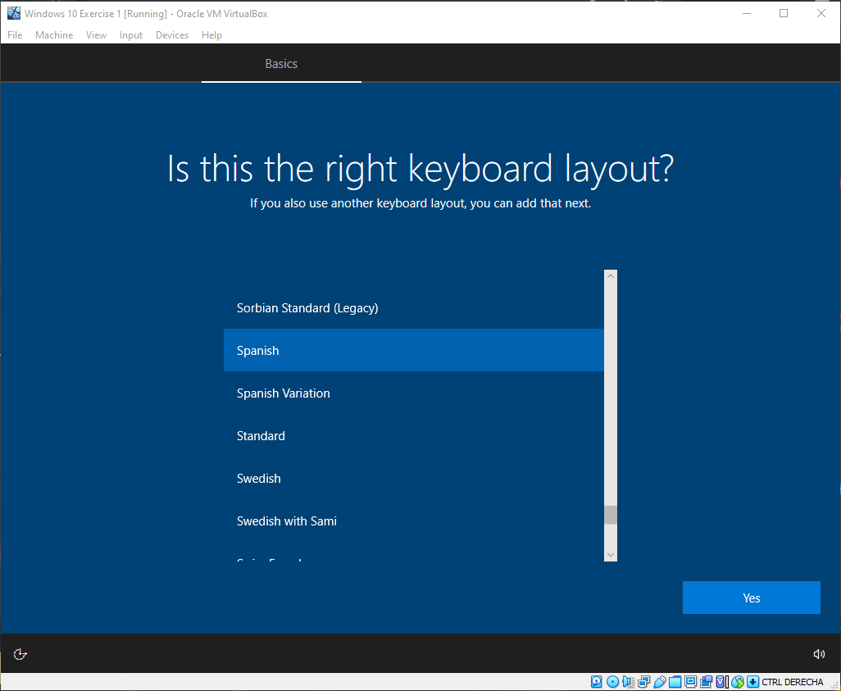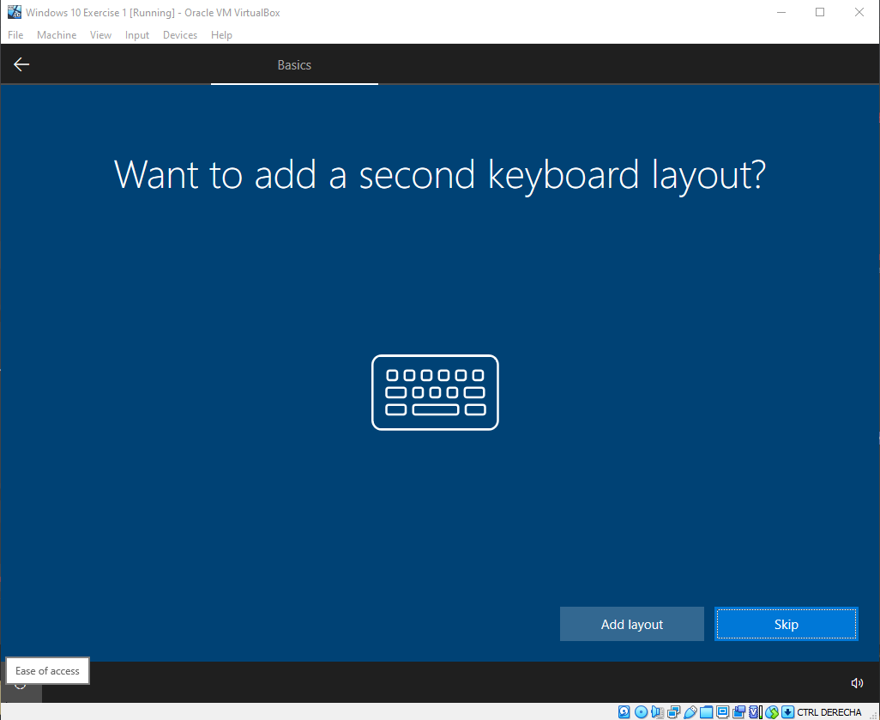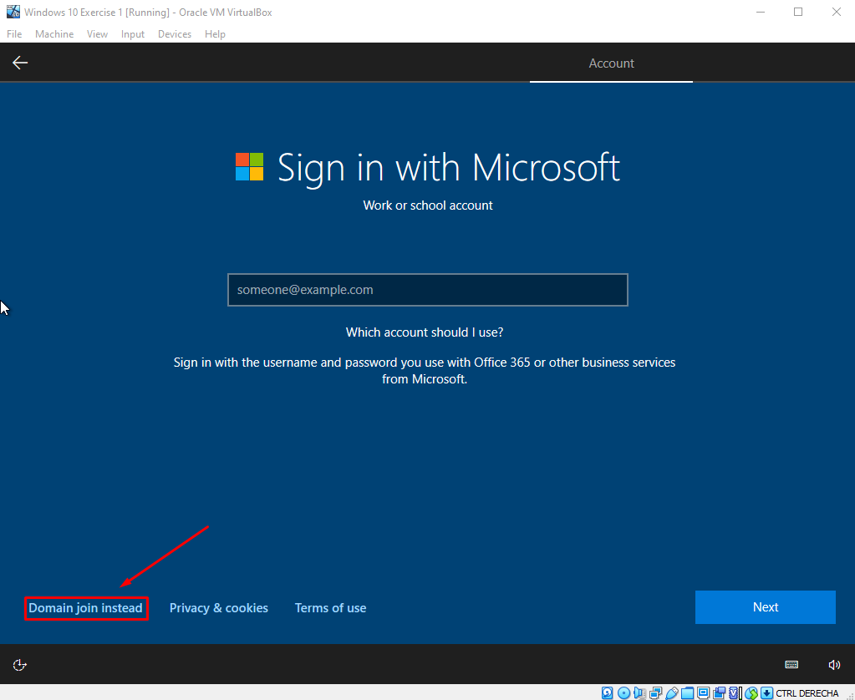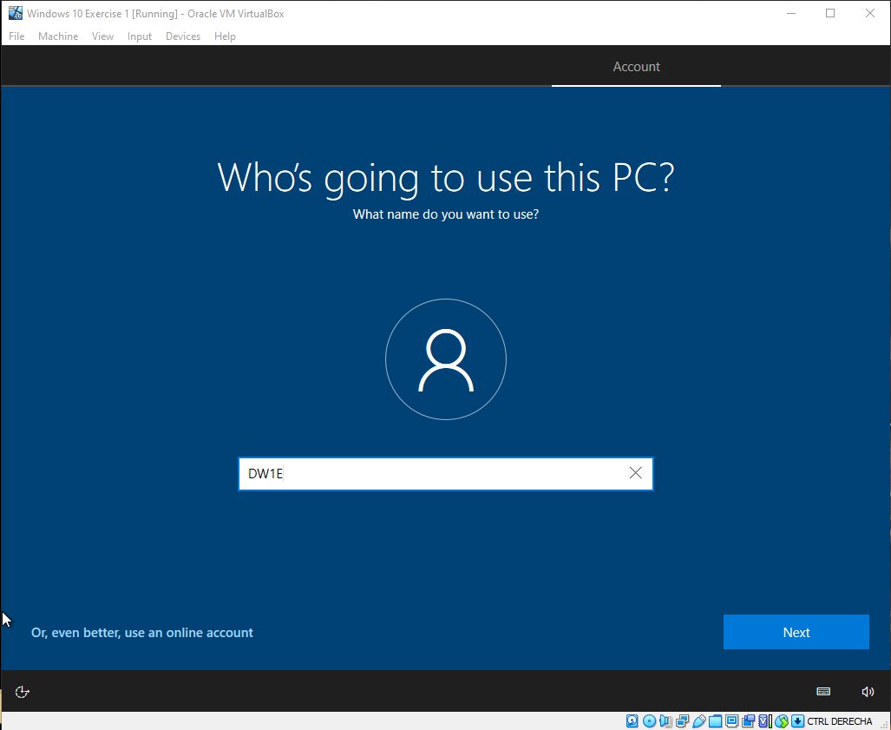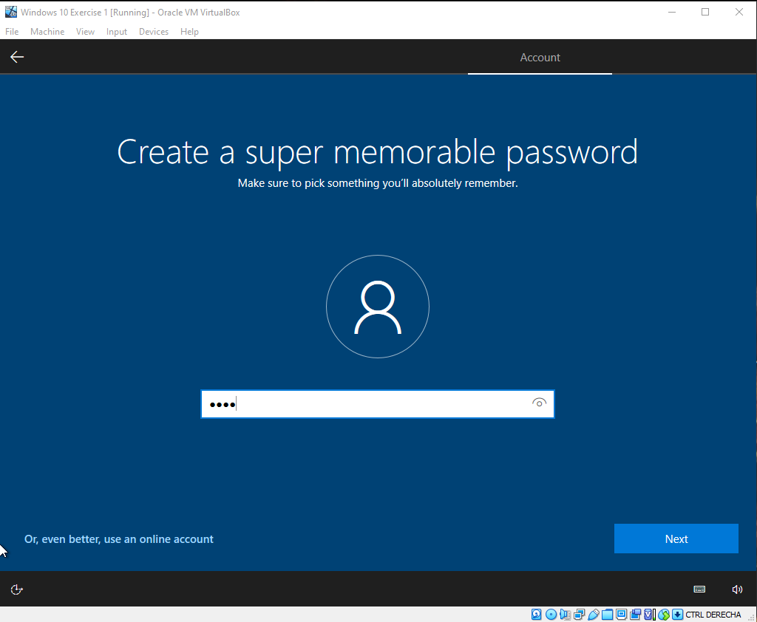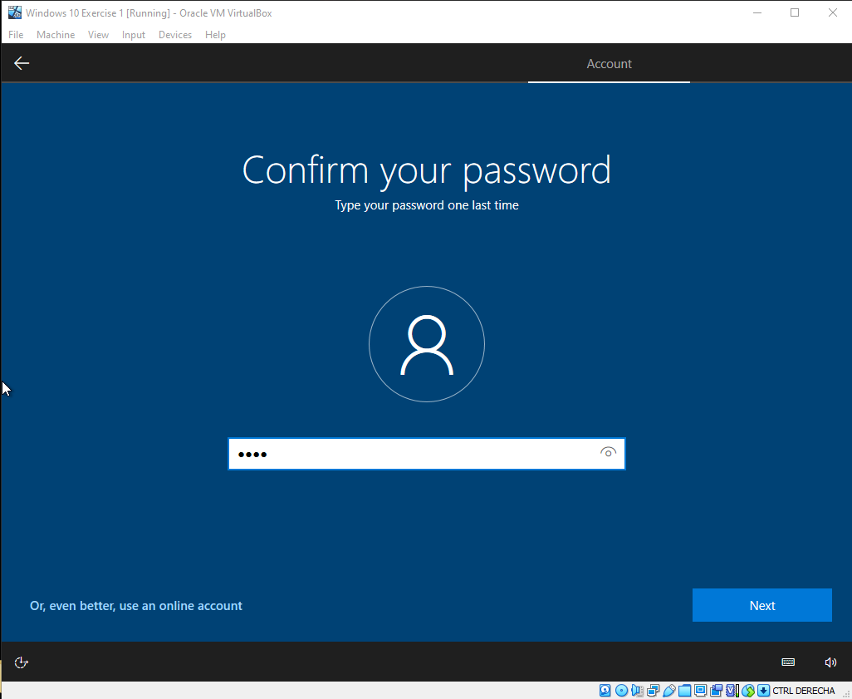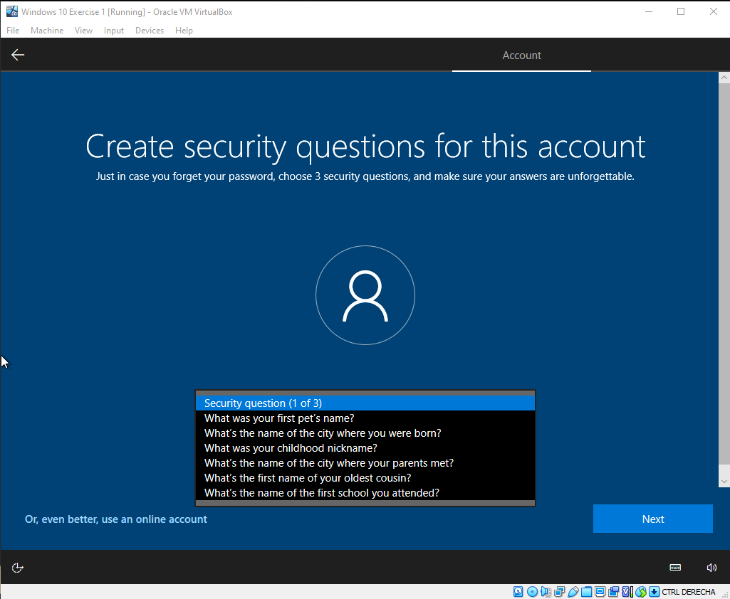
(SELECT 3 AND MAKE SURE TO REMEMBER YOUR ANSWERS)
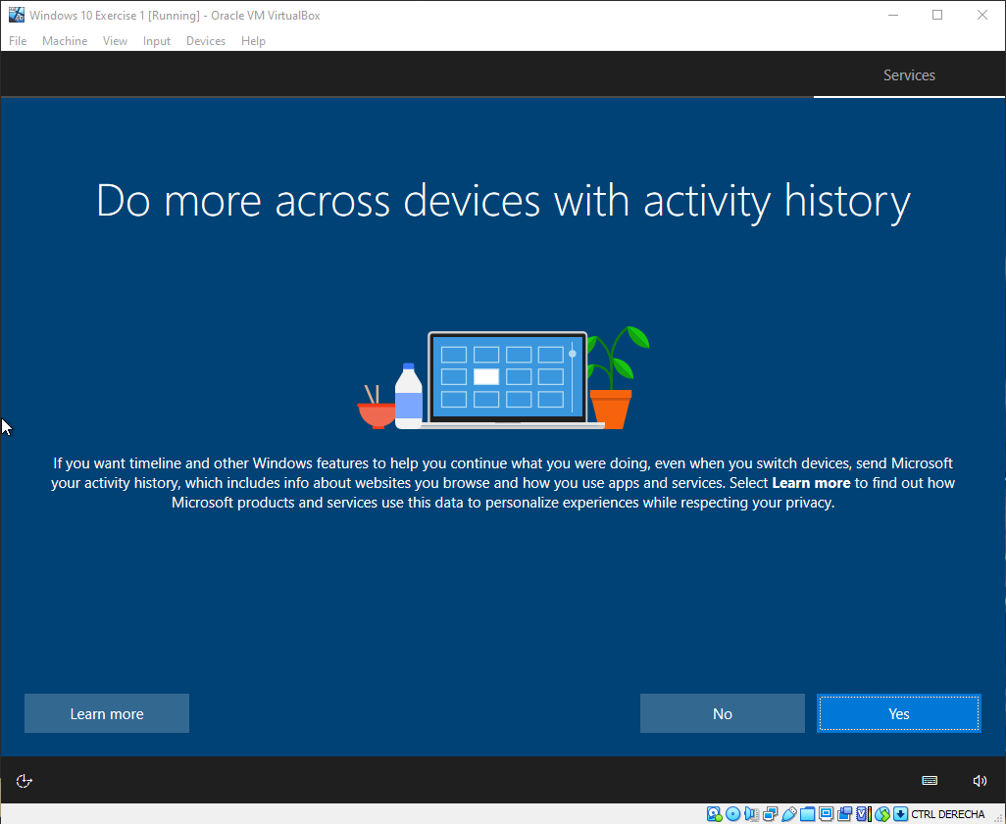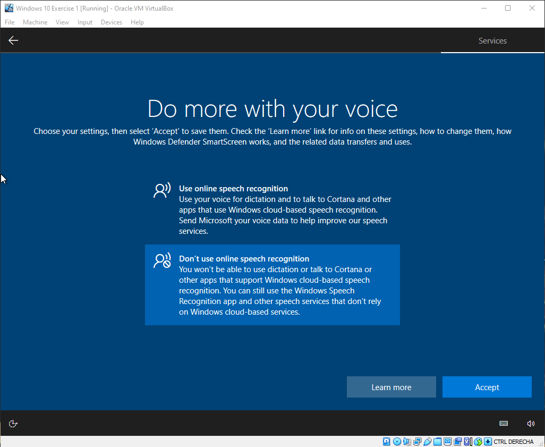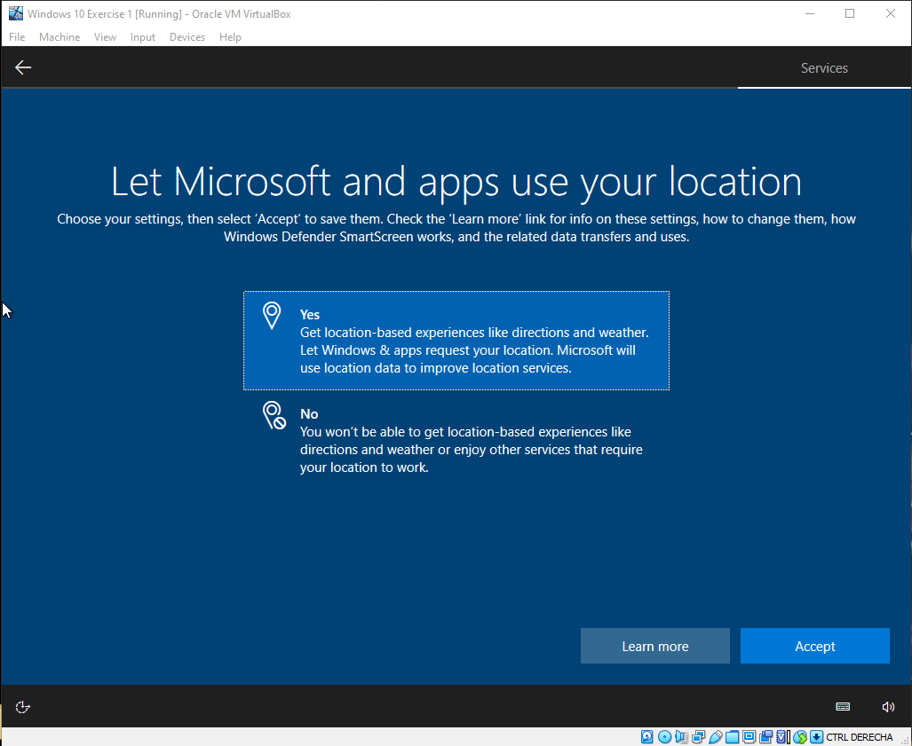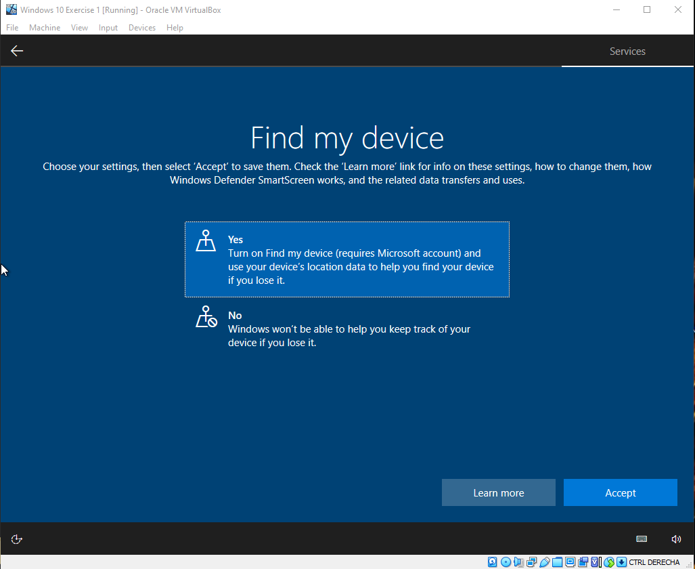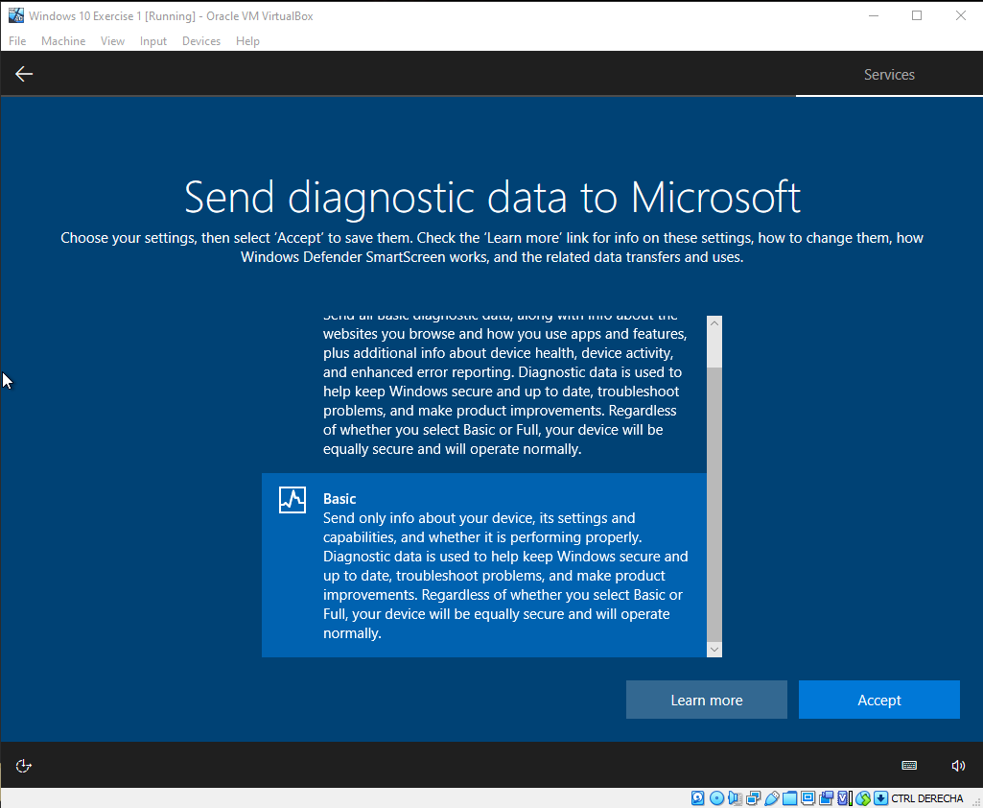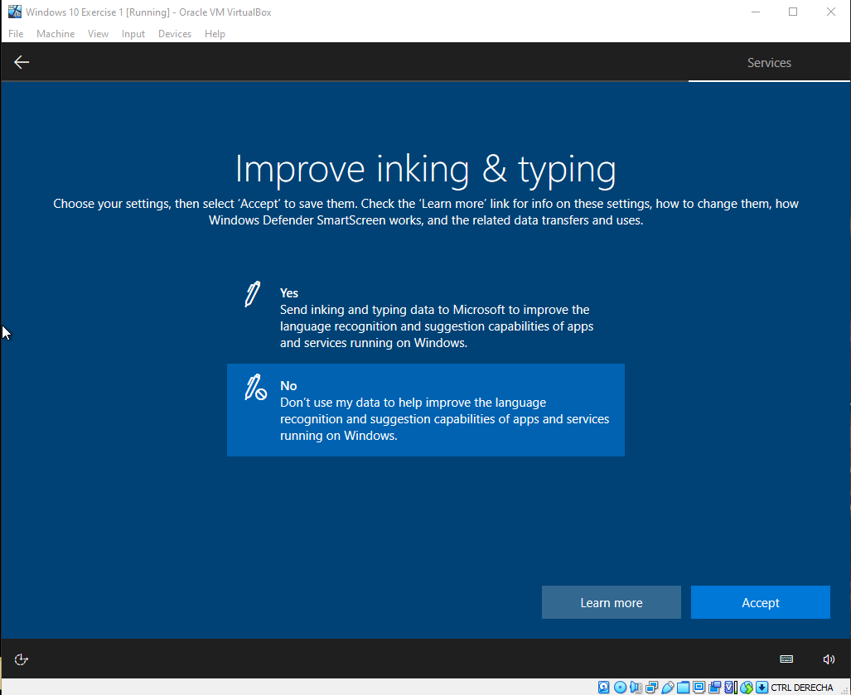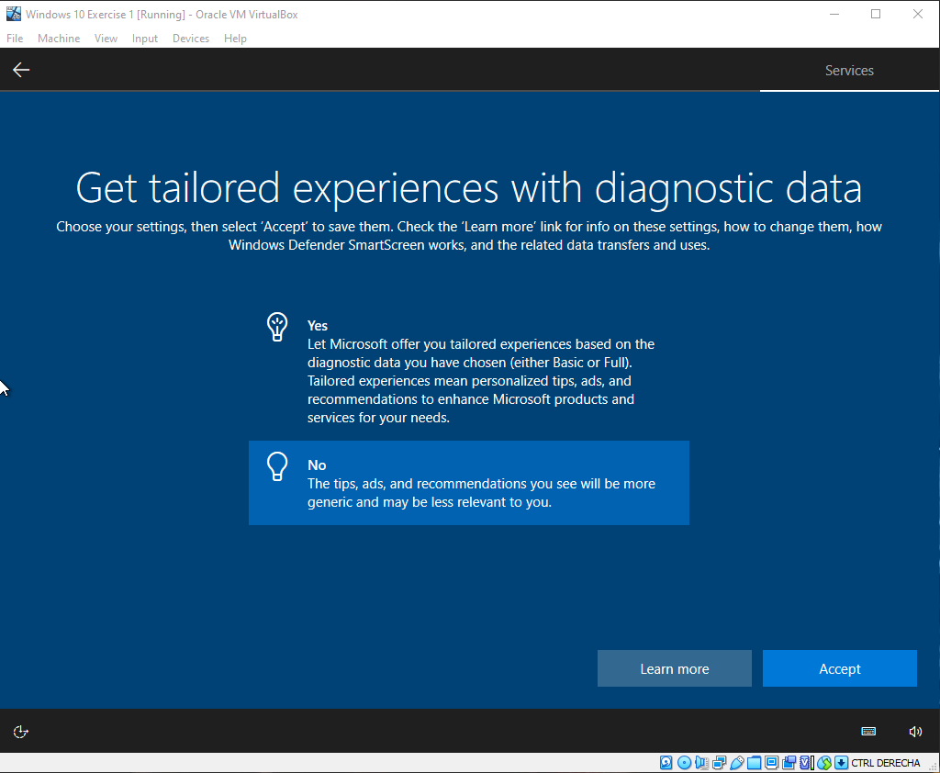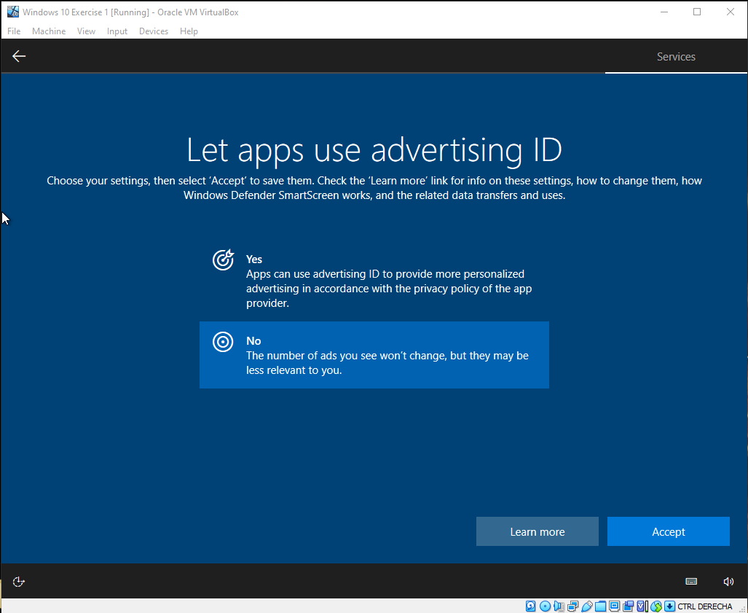

Finally, when every configuration has ended, we will press “Devices” (option seen on the VirtualBox’s window), and then click “Insert Guest Additions CD...”. This setting will create a more direct interaction between the virtual and the physical machine.
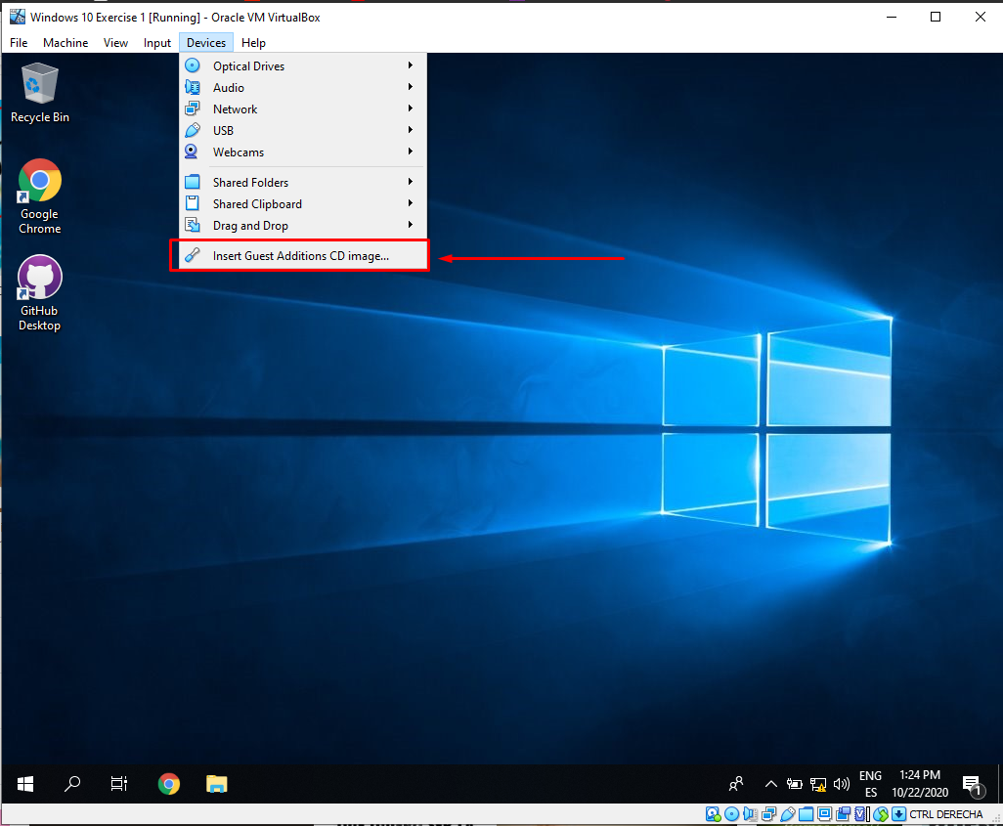
(If this method does not work, you can also go to your File Explorer, look at the left part, were all the different sections of the computer are, look for the Guest Additions CD and install it)

At this point, you will have Windows 10 ready for your use!

ALFREDO PUERTA GALLEGO - DW1E

